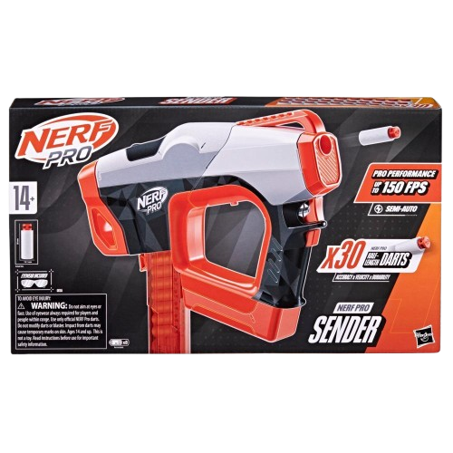****

**Nerf Pro Sender**

**Price: $24.99**

**Best to use and best product of Nerf**

**Delivers consistent, powerful shots with minimal effort.**

**The Nerf Pro Sender is a high-performance blaster designed for precision and power in Nerf competitions. Featuring advanced, professional-grade technology, this blaster is built for accuracy, shooting Nerf Pro darts that are engineered for greater distance and precision.**

**.**

.

**Product details**

**THANK YOU!**

**WELLCOME TO OUR WEBSITE**